Online Test Application

Source code

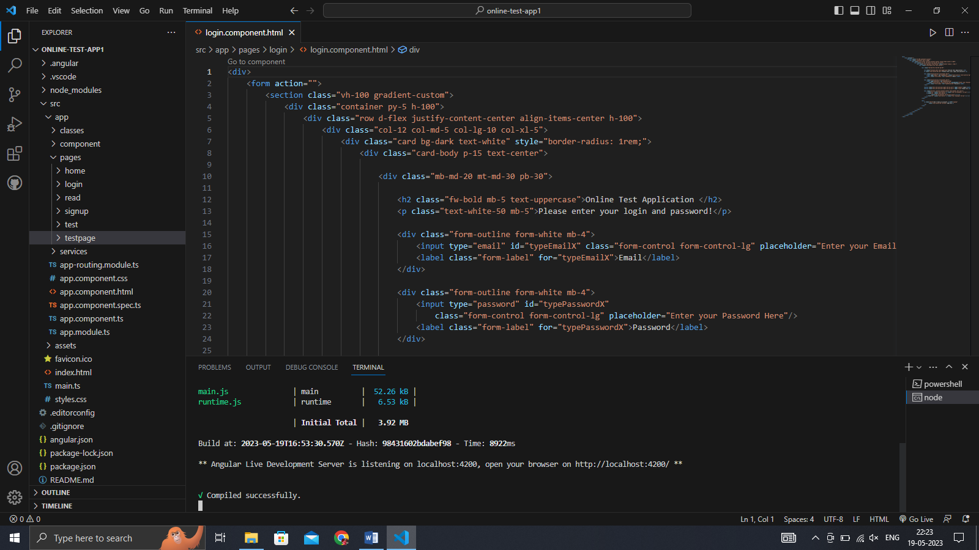

Login.component.html

<div>

    <form action="">

        <section class="vh-100 gradient-custom">

            <div class="container py-5 h-100">

                <div class="row d-flex justify-content-center align-items-center h-100">

                    <div class="col-12 col-md-5 col-lg-10 col-xl-5">

                        <div class="card bg-dark text-white" style="border-radius: 1rem;">

                            <div class="card-body p-15 text-center">

                                <div class="mb-md-20 mt-md-30 pb-30">

                                    <h2 class="fw-bold mb-5 text-uppercase">Online Test Application </h2>

                                    <p class="text-white-50 mb-5">Please enter your login and password!</p>

                                    <div class="form-outline form-white mb-4">

                                        <input type="email" id="typeEmailX" class="form-control form-control-lg" placeholder="Enter your Email Here"/>

                                        <label class="form-label" for="typeEmailX">Email</label>

                                    </div>

                                    <div class="form-outline form-white mb-4">

                                        <input type="password" id="typePasswordX"

                                            class="form-control form-control-lg" placeholder="Enter your Password Here"/>

                                        <label class="form-label" for="typePasswordX">Password</label>

                                    </div>

                                    <button class="btn btn-outline-light btn-lg px-5" type="submit">Login</button> &nbsp;

                                    <button class="btn btn-outline-light btn-lg px-5" type="reset">Reset All</button>

                                    <div class="d-flex justify-content-center text-center mt-2 pt-1">

                                        <a href="#!" class="text-white"><i class="fab fa-facebook-f fa-lg"></i></a>

                                        <a href="#!" class="text-white"><i

                                                class="fab fa-twitter fa-lg mx-4 px-2"></i></a>

                                        <a href="#!" class="text-white"><i class="fab fa-google fa-lg"></i></a>

                                    </div>

                                </div>

                                <div>

                                    <p class="mb-0">Don't have an account? <a href="signup"

                                            class="text-white-50 fw-bold">Sign Up</a>

                                    </p>

                                </div>

                            </div>

                        </div>

                    </div>

                </div>

            </div>

        </section>

    </form>

</div>

Login.component.css

.gradient-custom {

    /* fallback for old browsers */

    background: #6a11cb;

    /* Chrome 10-25, Safari 5.1-6 */

    background: -webkit-linear-gradient(to right, rgba(106, 17, 203, 1), rgba(37, 117, 252, 1));

    /* W3C, IE 10+/ Edge, Firefox 16+, Chrome 26+, Opera 12+, Safari 7+ */

    background: linear-gradient(to right, rgba(106, 17, 203, 1), rgba(37, 117, 252, 1))

    }

Navbar.html.component

<nav class="navbar navbar-expand-lg navbar-dark" style="background-color: #0D47A1;">

    <div class="container-fluid">

      <img src="https://www.pngkit.com/png/full/74-745921_education-online-test-photos-student-sitting-at-desk.png" alt="online test logo" height="80mm">

      <button class="navbar-toggler" type="button" data-bs-toggle="collapse" data-bs-target="#navbarSupportedContent" aria-controls="navbarSupportedContent" aria-expanded="false" aria-label="Toggle navigation">

        <span class="navbar-toggler-icon"></span>

      </button>

      <div class="collapse navbar-collapse" id="navbarSupportedContent">

        <ul class="navbar-nav me-auto mb-2 mb-lg-0" style="font-size: 5mm;font-weight: bold;">

          <li class="nav-item">

           <a class="nav-link active" aria-current="page" href="home">Home</a>

          </li>

          <li class="nav-item">

             <a class="nav-link active" aria-current="page" href="test">Online Test</a>

          </li>

          <li class="nav-item">

           <a class="nav-link active" aria-current="page" href="read">Read Books</a>

          </li>

        </ul>

        <a class="btn btn-danger" href="login" role="button">LogOut</a>

      </div>

    </div>

  </nav>

Signup.component..html

<body>

    <div>

      <form>

        <label>

          <p class="label-txt">ENTER YOUR NAME</p>

          <input type="text" class="input">

          <div class="line-box">

            <div class="line"></div>

          </div>

        </label>

        <label>

          <p class="label-txt">ENTER YOUR EMAIL</p>

          <input type="text" class="input">

          <div class="line-box">

            <div class="line"></div>

          </div>

        </label>

        <label>

          <p class="label-txt">ENTER YOUR PASSWORD</p>

          <input type="password" class="input">

          <div class="line-box">

            <div class="line"></div>

          </div>

        </label>

        <label>

          <p class="label-txt">ENTER YOUR CONFIRM PASSWORD</p>

          <input type="password" class="input">

          <div class="line-box">

            <div class="line"></div>

          </div>

        </label>

        <button type="submit">submit</button>&nbsp;

        <button type="reset">Reset All</button>

        <div>

          <p class="mt-2">Already have an account? <a href="login"

                  class="text-white-10 fw-bold">LogIn Here</a>

          </p>

      </div>

      </form>

    </div>

  </body>

Signup.component..css

body {

    background: #C5E1A5;

  }

  form {

    width: 60%;

    margin: 60px auto;

    background: #efefef;

    padding: 60px 120px 80px 120px;

    text-align: center;

    -webkit-box-shadow: 2px 2px 3px rgba(0, 0, 0, 0.1);

    box-shadow: 2px 2px 3px rgba(0, 0, 0, 0.1);

  }

  label {

    display: block;

    position: relative;

    margin: 40px 0px;

  }

  .label-txt {

    position: absolute;

    top: -1.6em;

    padding: 10px;

    font-family: sans-serif;

    font-size: .8em;

    letter-spacing: 1px;

    color: rgb(120, 120, 120);

    transition: ease .3s;

  }

  .input {

    width: 100%;

    padding: 10px;

    background: transparent;

    border: none;

    outline: none;

  }

  .line-box {

    position: relative;

    width: 100%;

    height: 2px;

    background: #BCBCBC;

  }

  .line {

    position: absolute;

    width: 0%;

    height: 2px;

    top: 0px;

    left: 50%;

    transform: translateX(-50%);

    background: #8BC34A;

    transition: ease .6s;

  }

  .input:focus+.line-box .line {

    width: 100%;

  }

  .label-active {

    top: -3em;

  }

  button {

    display: inline-block;

    padding: 12px 24px;

    background: rgb(220, 220, 220);

    font-weight: bold;

    color: rgb(120, 120, 120);

    border: none;

    outline: none;

    border-radius: 3px;

    cursor: pointer;

    transition: ease .3s;

  }

  button:hover {

    background: #8BC34A;

    color: #ffffff;

  }

Test.component.html

<app-navbar></app-navbar>

<body>

    <div style="

    margin:20mm;

        border-style: solid;

        border-radius: 10mm;

        background-color:rgba(127, 136, 255, 0.545);

        padding: 10mm;

        color: aliceblue;

        font-weight:bold ;

        font-size: 5mm;

        ">

        <h2>Rules:</h2>

        <p>1. Every Question Have to Attemp Compulsory</p>

        <p>2. For Every Question you will Have 60sec</p>

        <p>3. For Every Right Question you will Have 10 marks</p>

        <a class="btn btn-primary" href="testpage" role="button">Let's Start Test</a>

    </div>

</body>

test.component.css

body{

  height: 100vh;

        width: 100%;

        background-image: url('https://images.unsplash.com/photo-1454165804606-c3d57bc86b40?ixlib=rb-4.0.3&ixid=MnwxMjA3fDB8MHxzZWFyY2h8Nnx8b25saW5lJTIwZXhhbXxlbnwwfHwwfHw%3D&auto=format&fit=crop&w=500&q=60');

        background-repeat: no-repeat;

        background-size: cover;

        padding: 2mm;

}

Testpage.component.html

<body>

    <div class="container mt-sm-5 my-1">

        <div class="question ml-sm-5 pl-sm-5 pt-2">

            <div class="py-2 h5"><b>Q. which option best describes your job role?</b></div>

            <div class="ml-md-3 ml-sm-3 pl-md-5 pt-sm-0 pt-3" id="options">

                <label class="options">Small Business Owner or Employee

                    <input type="radio" name="radio">

                    <span class="checkmark"></span>

                </label>

                <label class="options">Nonprofit Owner or Employee

                    <input type="radio" name="radio">

                    <span class="checkmark"></span>

                </label>

                <label class="options">Journalist or Activist

                    <input type="radio" name="radio">

                    <span class="checkmark"></span>

                </label>

                <label class="options">Other

                    <input type="radio" name="radio">

                    <span class="checkmark"></span>

                </label>

            </div>

        </div>

            <div id="prev">

                <a href="#" class="previous round">&#8249;</a>

                &nbsp;&nbsp;&nbsp;

                <a class="btn btn-primary" href="home" role="button">Home</a>

                &nbsp;&nbsp;&nbsp;

                <a href="#" class="next round">&#8250;</a>

        </div>

    </div>

</body>

Testpage.component.css

body{

    height: 100vh;

    background-image: url('https://encrypted-tbn0.gstatic.com/images?q=tbn:ANd9GcRPgvI-f_8gFrn8NKeJ2CD4gkfsWyAyYMXivg&usqp=CAU');

    background-color: whitesmoke;

    background-size: cover;

    padding: 2mm;

}

@import url('https://fonts.googleapis.com/css2?family=Montserrat&display=swap');

*{

    margin: 0;

    padding: 0;

    box-sizing: border-box;

}

body{

    background-color: #333;

}

.container{

    background-color: #555;

    color: #ddd;

    border-radius: 10px;

    padding: 20px;

    font-family: 'Montserrat', sans-serif;

    max-width: 700px;

}

.container > p{

    font-size: 32px;

}

.question{

    width: 75%;

}

.options{

    position: relative;

    padding-left: 40px;

}

#options label{

    display: block;

    margin-bottom: 15px;

    font-size: 14px;

    cursor: pointer;

}

.options input{

    opacity: 0;

}

.checkmark {

    position: absolute;

    top: -1px;

    left: 0;

    height: 25px;

    width: 25px;

    background-color: #555;

    border: 1px solid #ddd;

    border-radius: 50%;

}

.options input:checked ~ .checkmark:after {

    display: block;

}

.options .checkmark:after{

    content: "";

    width: 10px;

    height: 10px;

    display: block;

    background: white;

    position: absolute;

    top: 50%;

    left: 50%;

    border-radius: 50%;

    transform: translate(-50%,-50%) scale(0);

    transition: 300ms ease-in-out 0s;

}

.options input[type="radio"]:checked ~ .checkmark{

    background: #21bf73;

    transition: 300ms ease-in-out 0s;

}

.options input[type="radio"]:checked ~ .checkmark:after{

    transform: translate(-50%,-50%) scale(1);

}

.btn-primary{

    background-color: #555;

    color: #ddd;

    border: 1px solid #ddd;

}

.btn-primary:hover{

    background-color: #21bf73;

    border: 1px solid #21bf73;

}

.btn-success{

    padding: 5px 25px;

    background-color: #21bf73;

}

@media(max-width:576px){

    .question{

        width: 100%;

        word-spacing: 2px;

    }

}

a {

    text-decoration: none;

    display: inline-block;

    padding: 8px 16px;

  }

  a:hover {

    background-color: #ddd;

    color: black;

  }

  .previous {

    background-color: #f1f1f1;

    color: black;

  }

  .next {

    background-color: #04AA6D;

    color: white;

  }

  .round {

    border-radius: 50%;

  }

Read.component.html

<app-navbar></app-navbar>

<body>

    <a class="btn btn-primary" href="https://www.javatpoint.com/java-tutorial" role="button">java-tutorial</a> <br><br>

    <a class="btn btn-primary" href="https://www.javatpoint.com/spring-boot-tutorial" role="button">java-SpringBoot</a> <br><br>

    <a class="btn btn-primary" href="https://www.javatpoint.com/mysql-tutorial" role="button">MySQL</a> <br><br>

</body>

Read.component.css

body{

    height: 100vh;

    width: 100%;

    background-image: url('https://plus.unsplash.com/premium_photo-1678565999332-1cde462f7b24?ixlib=rb-4.0.3&ixid=MnwxMjA3fDB8MHxwaG90by1wYWdlfHx8fGVufDB8fHx8&auto=format&fit=crop&w=1170&q=80');

    background-repeat: no-repeat;

    background-size: cover;

    padding: 2mm;

  }

app-routing.module.ts

import { NgModule } from '@angular/core';

import { RouterModule, Routes } from '@angular/router';

import { LoginComponent } from './pages/login/login.component';

import { SignupComponent } from './pages/signup/signup.component';

import { HomeComponent } from './pages/home/home.component';

import { TestComponent } from './pages/test/test.component';

import { ReadComponent } from './pages/read/read.component';

import { TestpageComponent } from './pages/testpage/testpage.component';

const routes: Routes = [

  { path: '', redirectTo: 'login', pathMatch: 'full' },

  { path: 'login', component: LoginComponent, pathMatch: 'full' },

  { path: 'signup', component: SignupComponent, pathMatch: 'full' },

  { path: 'home', component: HomeComponent, pathMatch: 'full' },

  { path: 'test', component: TestComponent, pathMatch: 'full' },

  { path: 'read', component: ReadComponent, pathMatch: 'full' },

  { path: 'testpage', component: TestpageComponent, pathMatch: 'full' }

];

@NgModule({

  imports: [RouterModule.forRoot(routes)],

  exports: [RouterModule]

})

export class AppRoutingModule { }

app.component.html <router-outlet></router-outlet>